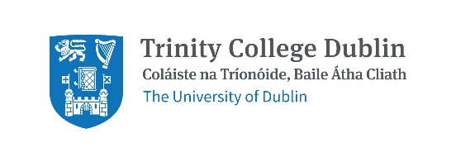
Trinity College Dublin
School of Natural Sciences
Department of Botany Transition Year Programme
25th – 29th March 2019

Application notes:
- Application deadline: Friday 1st February 2019
- Please only submit an application if you can commit to the full week-long programme.

Return this application form via email to saundem@tcd.ie or post to:

Dr Matthew Saunders
School of Natural Sciences
Botany Building
Trinity College Dublin
College Green
D2
Dublin

Please complete each section below in full.

- Applicant name:

- Have you applied for TY experience elsewhere in Trinity College (Yes/No):

- If yes, please indicate the Department/School:

- Your contact details:

  - Home address:

  - Email address:

  - Mobile number:

  - Landline number:

- School contact details:

  - School name and address:

  - Name of School TY Coordinator:

  - School Phone Number:

- Junior Certificate results:

  - Please list all subjects studied, including the grade awarded and indicate if higher or lower level:

- Personal statement:

  - Please write a statement outlining your interest in this subject, your reasons for applying to the TCD Botany Department and the impact this course would have on your academic development (continue on a separate page as necessary).

